PERTH NATUROPATHY - PATIENT SYMPTOM INFORMATION
MEDICAL HISTORY
NAME:_________________________
DOB:__________________________ Country/City of Origin:_______________________
PHONE:_______________________ MOBILE: ____________________________
ADDRESS:__________________________________________________________
OCCUPATION: ______________________________________________________
Email: __________________________________
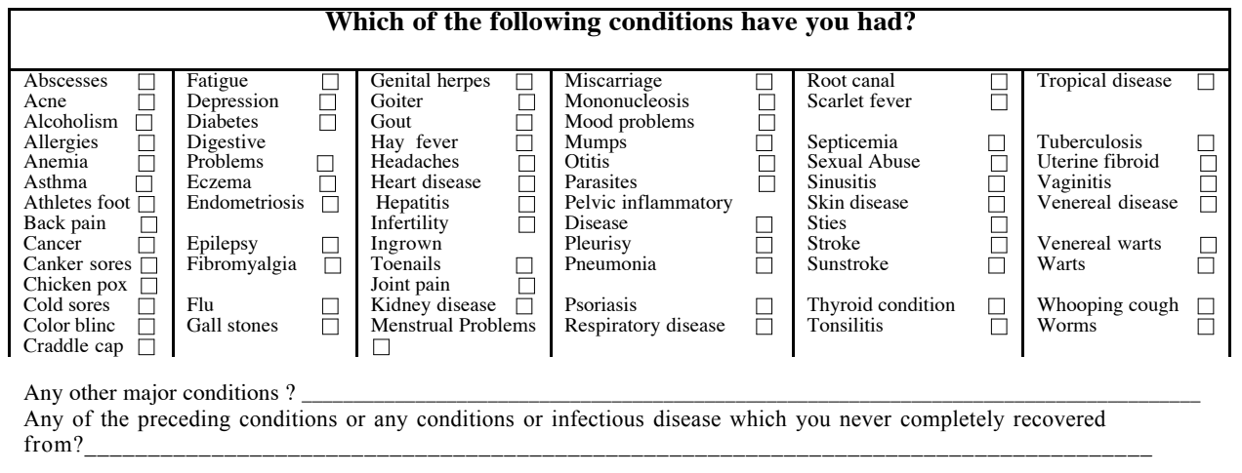
Referred by: _____________________________ 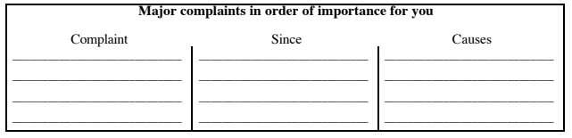

Please complete this timeline in detail, including viruses, doctor visits, prescribed medication, injuries, hospitalisations and operations (as accurate as possible)
We need to know your health events in the same order that they occurred.

ADVANCED INFO-Country & City of Birth ________________ Time of birth:______am / pm
0 - 5 yrs: (including any problems in-utero or during birth delivery)

5 -10 yrs:

10 -20yrs

20-30 yrs:

30-40 yrs:

40-50 yrs:

50-60 yrs:

60+yrs:

Have you had any reactions to vaccinations? If so, which one(s) and at what age?

If you had a reaction of any kind to any vaccination, what were the symptoms?

Any severe effects from any childhood illnesses?

Did you suffer from recurring:
y/n | chest infections or coughs | y/n | ear, nose & infections
y/n | skin problems | y/n | stomach pains
y/n | nose bleeds | y/n | headaches

Approximately how many courses of antibiotics have you taken in your life? What type of Antibiotic?

Are you aware of any effects of antibiotics on your health, particularly your digestion?

Have you had glandular fever or other significant virus? If so, at what age?

TESTS
Please list medical tests you have had, in chronological order:
TYPE OF TEST | DATE | REASON | RESULT
□ Blood test(s)
□ X Ray(s)
□ CT scan
□ Ultrasound
□ Hearing test
□ Other

Family History
Please describe all known diseases of the following family members eg heart disease; high blood pressure; diabetes; cancer; skin problems (eg psoriasis); TB; allergies; mental illness; alcoholism etc

Mother

Father

Immediate family (brothers, sisters, grandparents, aunts and uncles;

Anything else you would like to mention?

Symptoms
I need to know in as much accurate detail as possible the actual symptoms you experience (not necessarily just test results).

Its best to think about your problems and take some notes which you can show me at the clinic on the day of your consultation.

Also writing down a timeline of events is helpful.

Your main complaint

I need to know the LOCATIONS I need very accurate locations you feel symptoms.

I also need to know the actual SENSATIONS you feel, in your own words (see examples of sensations at end of document for help describing).

I need to know about the MODALITIES of the sensation/complaint/ condition. (What are the influencing factors of the sensation? What action or situations temporarily alleviate or aggravate the pain or condition?)

HOW WOULD YOU DESCRIBE YOUR PERSONALITY:
(This system of medicine includes all aspects of ones experience – the more I can know you on a deeper level, the more complete the treatment can expect to be.)

Other complaints you have had in the past

Symptoms which you feel are irrelevant/ not important (can be important for analysis)

SOME EXAMPLES OF SENSATIONS
- Boring / penetrating  - as if blows, jerks, punches, shocks, thrust, jarring  - as if broken  - as if Bruised  - as if Burning  - Burrowing (churning, rummaging, stirring)  - as if coated  - Constriction or contraction (band like or ligature)  - Choking  - Retraction  - Squeezing together  - Cramping (clamped, as if in a clamp or vice)  - Cracking sensation  - Cutting pain  - Dull pain  - Emptiness  - Fullness | - Gnawing (corroding, eating away at)  - Grasping ( clutching, griping, as in colic)Pinching  - as if from Growing pains  - Gurgling  - Hanging down sensation  - Heaviness  - Lightness  - Lump sensation  - Narrowing sensation  - Blocked or Obstructed sensation  - Paralytic pain (crippling, lameness)  - Pressing (aching)  - Urgings (forcing, pressing, as in stool) sensation  - Pulsation or Throbbing | - Scraping sensation  - Crawling  - Vibrating/prickling (pins & needles)  - NumbingSensitivity, increased sensation in general  - Soreness (excoriating pain)  - as if Sprained  - Stinging (biting, smarting)  - Stitching ( piercing, pricking)  - Tearing (drawing or dragging)  - Tension (tightness)  - Twinges (sudden or fleeting pains)  - Twitching sensations  - Ulcerating pain  - Water beating, bubbling sensation.

SOME EXAMPLES OF MODALITIES
(PLEASE TRY – where possible- to actually find out the effects better/worse on each of your conditions from the following- )

- Effects from Temperature, Hot or Cold (applications, becoming)?  - Effects from Weather (hot, cold, humid, rainy, windy, fogy, before storms etc) ?  - Changes of weather or Season?  - Effects on your condition from different Emotions?  - Definite effects from specific Foods or Beverage?  - Ascending (stairs, incline etc)  - Bending – affected parts  - Blowing nose  - Boring with the finger ( in ear or nose)  - Chewing  - Clothing (pressure from)  - Being in Company or Crowds  - During, before or after Coughing  - Crossing limbs  - in the Dark  - Drinking  - before, during or after Eating  - from Burping  - from mental Exertion  - Physical exertion (what type?)  - Exerting the Eyes  - closing Eyes  - before, during or after Fever or Chill  - after passing Flatus?  - Brushing Hair  - Holding or grasping something  - from Hiccoughing  - from Hunger  - Since Injuries in general?  - Jarring | - Kneeling  - Knocking against something  - Laughing  - Leaning on something  - is it worse during Leucorrhea (for females)?  - Light in general?  - Effects of Lying down?  - -on back, side, which side (painless or painful side) , what position?  - is it better or worse before, during or after Menstruation, Intercourse etc?  - Effects from Opening mouth?  - effects from Movement in general? (effects from movement on your complaint)  - -during, after movement?  - -during continued movement?  - -movement of facial muscles?  - effects on your condition from MUSIC/ sound & noise?  - effects from Odours?  - Changing your position?  - effects from PRESSURE? (actually press on the part to find out)  - effects from Raising your Limbs?  - effects from Reading?  - effects from Breathing in & out, from holding breath, from deep breathing? | - effects from retracting in your Abdomen?  - effects from Riding in a car?  - effects on Rising, from chair, from bed etc?  - effects from a closed Room?  - effects from Rubbing the part?  - effects from Sexual excess or activities on your condition in general?  - effects from Sitting, bent or upright?  - effects before, during & after Sleep?  - effects from Sneezing?  - from smoke?  - effects from or whilst Standing?  - from Stepping hard?  - effects before, during & after passing a Stool & urination?  - effects from Stooping?  - from stretching?  - effects from Swallowing?  - effects from Talking or Singing?  - from biting teeth together?  - effects from Touch, light or hard?  - effects from Vomiting?  - effects from beginning to Walk, during & after Walking?  - effects from Crying?  - from Writing?  - from Yawning?

You can print this info out, take notes and bring it along or email to darren@perth-naturopathy.com.au

